PROJECT REPORT

On

Six Month Industrial TrainingcumProject

**Designing of Free Space Optical Communication Network under Different Weather Conditions**



**Submitted by:**

Name:-Vishal Kumar

Semester:-8thSEM (CE)

Roll.No-11401039

**Under the Supervision of**

**Dr. Amardeep Singh**

**Professor and Head**

**Department of Computer Engineering, Punjabi University,Patiala**

**May 2018**

TABLE OF CONTENTS

acknowledgment 3

preface 4

certificate 5

about the organisation 6

chapter 1- inroduction 7

1 introduction 7

2 types of communication systems 17

3 network topologies 19

4 optisystem software 22

chapter 2- performance investigation of FSO network under different weather conditions 28

1 introduction 28

2 proposed hybrid topology network 30

3 result and discussion 34

4 conclusions 40

references 41

ACKNOWLEDGEMENT

It is indeed a privilege as well as a pleasant duty to express our gratitude to all those who have made it possible for me to complete this training. It is a matter of great pleasure for me for submitting a project on “**Designing of Free Space Optical Communication Network under Different Weather Conditions**”. I express my deepest sense of gratitude to my project guide **Dr. Amardeep Singh**, whose invaluable and incomparable guidance and blessings has made possible the completion of this challenging project.

**Vishal Kumar**

**PREFACE**

Free Space Optical (FSO) communications, also known as Free Space Photonics (FSP) or Optical Wireless, concerns to the transmission of visible or infrared (IR) beams through the atmosphere to obtain optical communications. During this course of work, the designing of FSO network totally depends upon the atmospheric attenuation. Different weather conditions have different attenuations, which causes signal degradation on the basis of scattering, visibility etc. A rain season shows the maximum attenuation, in which beam of signal scattered due to the raindrops.In this work, the FSO communication network is proposed using network different topologies between the two cities. During this course of work, the region of Patiala and Rajpura, Punjab, India has been taken and investigated network’s performance under different weather seasons. This work has been designed to adhere the eventuality of FSO communication in the proposed network with the wavelength of 1550 nm onwards. In this report, the two ring networks are designed in the two cities respectively, which are also connected with free space optical channel with relative line of sight distance. The simulation results have been adhered by anatomizing the bit error rate and Quality factor with power alteration according to weather conditions. During this work, an optical amplifiers/repeaters have been used in certain weather conditions to achieve the acceptable results at each node.

**Certificate**

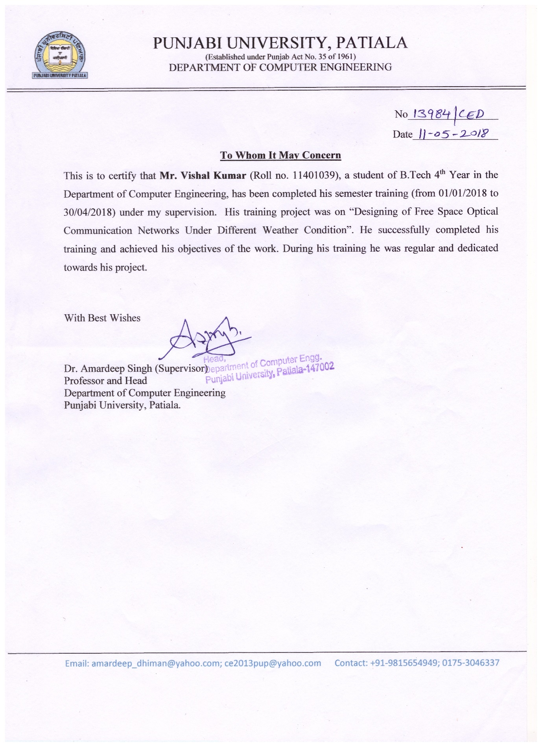

**About the Organization**

The Computer Engineering Department, Punjabi university Patiala was established in 2003, after consultations between the senior faculty of the University, technical experts and the Vice-Chancellor regarding the need for education in the field of engineering and technology in the state of Punjab. Earlier it was known as University College of Engineering (UCoE), Punjab, India,

The university has drawn up a master plan to be executed in three phases to provide technical education in the basic and specialized fields. Three branches leading to B.Tech. degree have been offered in the first phase. The second phase will introduce another three branches namely Micro-electronics, Power Engineering and Bio-informatics and the third phase will include further expansion, and stress on research work and establishment of a research and development centre with the participation of industry. This centre would provide solutions to the technical problems of the industry and would suggest means for growth of industry in the region.

A central placement cell has been established by Punjabi University for arranging the training and final placement of its students. Companies like Maruti Suzuki, TechMahindra, L&T, Infosys, Wipro, SAP, TATA Motors, Google, Facebook, Aricent, Airtel, Idea Cellular visit the campus every year. The cell is in touch with industry houses and arranges on and off campus interviews of its students with the executives of the industry.

Clubs for technical, cultural and literary subjects have been formed by the students.

The Punjabi University is committed to develop UCoE as a Centre of Excellence in Technical Education

**Chapter 1: Introduction**

**1.1 INTRODUCTION TO FREE SPACE OPTICS (FSO)**

FSO provides point-to-point transmission using the Optical signals as the carrier frequencies.

Due to its cost effectiveness, easy installation, quick initiation of communication link especially in the emergency conditions, wide range of applications, it has drawn attention in Telecommunication industry. FSO operates at very high frequency which makesCommunication free of licensing. FSO involves the optical transmission of voice, video using air as the medium of transmission FSO systems are provide full duplex capability[1].To obtain optical communications, FSO refers to the transmission of modulated visible or Infrared beams through the atmosphere, where the atmospheric attenuation is usually themain source of penalty.

For spacecraft communications FSO are additionally used. The optical links can be deployed using infrared laser light, although using LEDs, low-data rate communication over short distances is possible. [2]. It is considered as same as to wireless radio link line-of sight (LOS) communication systems. The stability and quality of the link is highly dependent on atmospheric factors such as rain, fog, dust and heat. Amateur radio operators have achieved significantly farther distances but maximum range for terrestrial links is in the order of 2-3 km. FSO components are contain three stages: Transmitter to transmit an optical radiation through the atmosphere, free space transmission channel where exist the turbulent odd factors (cloud, rain, smoke, gases, temperature variations, fog and aerosol) and receiver to process the received signal. The motivation for FSO is to decrease the cost, time, and installing effort of optic fiber cable, yet to retain the benefit of high data rates for trans-receiving of voice, data, images, and video [3]. A general idea of FSO network is shown in the Fig.1.1:

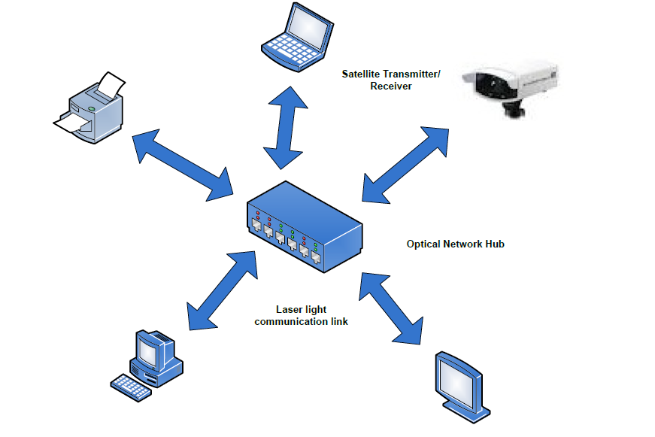

Fig.1.1 FSO Network.

* + 1. **FSO communication**

The transmitter of FSO communication transmits an optical carrier data which is then passed through an atmosphere to the receiver. The intensity modulation (IM) is the simplest modulation in which the source data is modulated on the intensity of the light. Laser is the commonly used source in FSO systems [4].

To estimate the transmitted data from the received optical signal is the main function of the receiver. A receiver telescope, an optical band-pass filter, a photo detector, and a detection circuit are main parts of the receiver. The receiver telescope collects and focuses the received signal onto the photo detector and to reduce the background noise use the optical band-pass filter. The photo detector such as PIN and avalanche photodiode (APD) converts the received optical signal into an electrical signal.

Finally, the received signal is recovered after amplification and filtering at the detection circuit [5]. FSO communication is a line-of-sight (LOS) technology

Which is operating the optical communications 1st,2ndand 3rd transmission windows Respectively at wavelengths of 850nm, 1300nm and 1550nm corresponding to these Wavelengths have low attenuation, less than 0.2dB/km, can use the same commercial components of an optical fiber and safe for eye and skin [6]. FSO has many applications which are discussed below:

* + - 1. Applications:

The applications of FSO links for transmission of modulated RF signals are as follows:

1. Outdoor wireless access: FSO can be used by wireless service providers for purposes of communication and licensing is not necessary in case of microwave bands to use the FSO.

2. Storage Area Network (SAN): FSO links can be form Storage Area Network. For providing access to combined, block level data storage SAN network is known [7].

3. Last-Mile Access: The cost of digging to lay fiber is so high as to lay cables of users in the last mile is very costly for vendor sources and it would make direction to lay as much fiber as possible. By implementing FSO in the last mile along with other networks, FSO can be used to solve such problem.

4. Enterprise connectivity: FSO system has a property of easy installation. This property makes it applicable for associating two or more LAN segments to connect two or more buildings blocks or other campus.

5. Fiber backup: In Fiber links, there is not any backup link in case of transmission failure. On the other hand, FSO can also be applicable in order to providing a backup link.

6. Metro-network extensions: Metro-network extensions can extend the fiber rings of an existing metropolitan area. Deployment in lesser time and connection of the new networks and core infrastructure of FSO system is easily done. In order to complete SONET rings, metro-network extensions can be used [8].

7. Bridging WAN Access: It provides services of high speed data to mobile users and small satellite terminals and in case of WAN, it works as a backbone for trucking network of high

Speed makes FSO beneficial [9].

8. It can be used in point-to-point communication links, for example, between buildings, ships, and point-to-multipoint communication links, for example, from aircraft to base station or satellite to base station, for short distance and long distance communication [10].

9. Military access: FSO works on optical source, which makes it secure and undetectable system. It can cover up large areas with smallest planning and deployment time, hence it is appropriate for military applications [11].

10. FSO is with high ability to control interference from other sources of optical radiation [12].

11. FSO provides a viable transport medium for transporting IS-95 CDMA signals to base stations from macro and microcell sites and can reduce the setup costs of temporary microcells deployed for special events, e.g., a football game, by eliminating the need for a directional microwave link or connecting cable [13].

12. FSO is a viable technology for the processing of CATV links in urban areas where

Installing new fiber infrastructure can be quite expensive [14].

* + - 1. Merits & Limitations:

FSO communication also has some merits and limitations that can affect the performance of the FSO system. Merits and limitation of FSO communication are discussed as:

Merits:

1) FSO is a high speed network, which delivers better data speed than broadband networks.

2) It takes less time as compared to other systems for installation at normal locations. So its installation is very easy and less time consuming.

3) No spectrum licensing or frequency coordination between users is required, which is required in radio and microwave systems. FSO is a straight forward deployment system.

4) No security system upgradation is needed because of line of sight operation.

5) The optical fiber cable’s data rate is comparable to obtained high data rate of FSO but the extremely narrow laser beam and very low error rate enables having unlimited number of FSO links that can be established in that specific area.

6) FSO offers high immunity to frequency interference [15].

7) The FSO link transmission cannot affected by Electromagnetic and radio-magnetic interference.

8) Usage of low power per transmitted bit is from one of the merit of FSO system.

9) In FSO system, the used bandwidth is relatively high bandwidth [16].

10) Transmission is having speed of light because transmission of optical beam is done in air [17].

Limitations:

The advantages of FSO are easy to come. In FSO system, medium of the trans-receiving is an air and there are some un-ignorable environmental challenges. In Troposphere region, the most of the atmospheric phenomenon are occurred [18]. Some of these limitations are briefly described below:

1. Physical obstructions: A temporary blockage a single beam, when any physical obstructions like birds, tall trees and buildings architectures comes in line of sight (LOS) and disturbs the transmission of FSO system.

2. Scintillation: Due to the heat rising from the earth and the man-made drives like heating ducts, there would be temperature variations among different air packets. These variations in temperature can cause fluctuations in the signal amplitude at the FSO receiving end [19].

3. Geometric losses: As signal travelled from transmitted end to receiver end, the induction of an optical beam attenuation because to the spreading of beam and reduced the signal power level is defined as geometric losses [15].

4. Absorption: The suspended water molecules in the terrestrial atmosphere cause absorption. The photons power would be absorbed by these particles. Absorption directly affects the decreased the optical beam power density and the transmission availability in a FSO system. The absorption of signal can also carried out by Carbon dioxide [20].

5. Atmospheric turbulence: Weather conditions and structure of environment causes the atmospheric disturbance. It happens because of wind and convection which mixed the air packets at different temperatures. This causes the change in the refractive index of air and causes fluctuations in the air density. Degradation of the optical beam of transmission can be led by turbulence. The refractive index change causes beam refraction at different angle and optical beam spreading takes place.

6. Atmospheric attenuation: The main causes of atmospheric attenuation are fog and haze. It also depends upon the other two causes are dust and rain. An atmospheric attenuation is wavelength independent. Haze is depends upon wavelength. In haze weather condition, attenuation at 1550nm is less than other wavelengths [18]. Fog weather condition attenuation is not depends upon wavelength.

7. Scattering: When the optical beam and scattered particle collides, scattering phenomena happens. In this energy of optical beam is not changed and it is wavelength dependent phenomenon. The beam intensity for longer distance is reduced because of directional redistribution of optical energy. Atmospheric attenuation is classified into three types [21]:

(1) Rayleigh scattering is due to molecules, and known as molecule scattering.

(2) Mie scattering is due to aerosols, and known as aerosol scattering.

(3) Nonselective scattering is due to geometric losses, and known as geometricscattering.

The type of scattering depends upon the physical size of the scatterer:

(i) When the size of wavelength greater than scatterer size, Rayleigh scattering

(ii) When the size of the wavelength is comparable to the scatterer, Mie scattering.

(iii) When wavelength is much smaller than the size of scatterer, nonselective scattering [19].

8. Weather Conditions of Atmosphere: In FSO link the medium of transmission is an Atmosphere. Attenuation depends upon several conditions. The main cause of attenuation is weather conditions. The preceding knowledge of attenuation can be gained according to the specific weather conditions of the region in which a link is being established; for example, in temperate regions, fog and heavy snow are the two primary weather conditions. On the other hand in tropical regions, heavy rain and haze are two main weather conditions and have major effect on the availability of FSO link in that region [22]. Some of the weather conditions are described as follow.

(a) Fog: It partially attenuates visible radiation. Due to the hindrance caused by fog an optical beam of light is absorbed, scattered, and reflected. Mie Scattering occurs due to fog [19], is largely a matter of increasing the power of transmitting.

(b) Rain: In case of rain fall, rain attenuation exists and is a nonselective scattering. This is type of wavelength independent attenuation [18]. The production of the fluctuations is due to rain, which affect the laser delivery. The quantity of the rain can effects the visibility and range of FSO system. In case of heavy rain, water droplets can modify the characteristics of optical beam or opposes the passage of beam as optical beam is absorbed, scattered, and reflected [16].

(c) Haze: These particles can stay longer time in the air and causes the atmospheric attenuation. So, the visibility level at that time changes attenuation values. There are ways to collect information about attenuation for checking the performance of FSO system: first, by temporary installation of system at the site and check its performance and, second, by using Kim and Kruse model [18].

(d) Smoke: It is generated due to the combustion of carbon, glycerol, and householdemission like different substances. The visibility of transmission medium can also be affectedby smoke [23].

(e) Sandstorms: For communication of outdoor links, the well-known problemis sand storms. These can be distinguished by two ways: first, the wind particles size thatdepends on the soil texture and, second, required wind speed in order to blow the particles upduring a minimum period of time [24].

(f) Clouds: Main part of earth atmosphere is cloud layers. The condensation or deposition of water above earth’s surface is responsible for the formation of clouds. It can totally block the fractions of transmitted optical beam from earth to the space. The attenuation offered by clouds is difficult to calculate because of the diversity and in the cloud particles homogeneity [25].

(g) Snow: Snow has larger particles, which causes the geometric scattering. The snow particles have impact same as to Rayleigh scattering [26].

* + 1. **Classification of FSO networks**

Due to their potential for a broad spectrum of applications, FSO networks have been investigated and proposed for networks that difference a distance from meters to over thousands of kilometers. According to the locations of optical transmitters and receivers and network range FSO networks can be classified into three types[27]:

* + - 1. Optical Wireless Satellite Networks (OWSNs) OWSNs

They are designed to cover large areas of the earth and provide high-bandwidth, optical wireless network access to end-users by making use of satellites [28]. OWSNs provide high quality data services to isolated areas such as an island, a remote farm, a ship on the ocean and an aircraft. OWSNs consist of intersatellite, satellite-to air, and satellite-to-surface optical links types of free-space links. For routing data traffic hop-by-hop through satellites toward a final destination satellite, Inter-Satellite Links (ISLs) are designated. It has up-and-down links between the aircraft or a ground station on the surface of the earth [29].

* + - 1. Optical Wireless Terrestrial Networks (OWTNs)

An establishment of LOS optical wireless connection between two transceivers through outdoor atmospheric turbulence channels as known as outdoor FSO networks or OWTNs [30]. The transmission distance through free atmospheric space is from hundreds of meters up to tens of kilometers because it requires LOS. This telecommunication paradigm has great potential for wireless communications and is becoming an important means for broadband internet access [31]. For instance, FSO links for ship-to-ship, building-to-building, or community-to-community communications can be established without any optical fibers. Mobile terminals are also easily supported. OWTNs are effective solutions for the “last-mile” or “first-mile” problems [32]. In optical fiber communication, there are still many end-users who do not have their own fiber connection to the Fiber to the Home (FTTH) service. OWTN provides a high bandwidth connection over a large distance for remote end-users [33].

* + - 1. Optical Wireless Home Networks (OWHNs) OWHNs

Also known as indoor FSO networks, they are desirable for wireless broadband communications inside houses and offices. OWHNs are used to establish a LAN comprised of cells, where each cell is one of the divided spaces in the building [34]. Usually each cell is free from interference from other neighboring cells. As a result, the same beam specifications are reused Based on different propagation modes, we further classify the indoor FSO links into two types:

• LOS links and,

• NON-LOS links, also known as diffused links[35].

A direct path between the sender and receiver requires in case of an LOS link. Any unwanted obstacles between the sender and receiver easily disturb the LOS link. Compared with non-LOS links, LOS links achieve higher capacity because of a better power budget and the absence of multipath propagation effects [36].

1.1.3 Various Techniques for generation of FSO System:

Various techniques for generation of FSO system are also used to increase the performance of system. Some of these techniques are discussed as:

1. Spectral Amplitude Coding Optical Code Division Multiple Access based

FSO system (SAC OCDMA Based FSO System).

2. High Speed, Long Reach OFDM (Orthogonal Frequency Division Multiplexing) FSO Transmission Link Incorporating OSSB (Optical Single Side Band) and OTSB (Optical Tendem Side Band) Schemes based FSO systems.

3. WDM FSO System [37].

a) Spectral Amplitude Coding Optical Code Division Multiple Access based FSO system (SAC OCDMA Based FSO System):

In FSO system, spectral amplitude coding optical code divisionmultiple access technique is used by the scientists. This multiplexing scheme has someadvantages like channel allocation flexibility, ability of asynchronously operative,Enhancement of privacy, and increase network capacity. To modulate the code sequence withdata an optical modulator (OM) is used. The data is digitally single-polar signal. Formodulation purpose, Mach-Zehnder modulator (MZM) is used and combined modulated codesequences are transmitted through the FSO link and at the receiver end, these sequences areseparated by an optical splitter. Decoder will only filter the non-overlapping chips and to avoidthe interference at receiver end, the overlapping chips are discarded. The purpose ofencoders and decoders can be served by optical band pass filters [38].

b) High Speed, Long Reach, OSSB and OTSB Schemes based FSO systems:

In order to show theimpact of the environment conditions and to design a high speed and long reach FSO systemfree from fading, this scheme has been made. Weather conditions like clear, foggy, and hazychannel are used to describe different types of condition in system. CW laser is used at theline-width of 10MHz and 1550nm wavelength. The hybrid system used power is 0 dBm andideal aperture of antenna is 15 cm. The bit rate is 5Gbps and a 4-QAM sequence generatorgenerates the data and OFDM modulator using 512 subcarriers is used. Using OTSB/OSSBschemes instead of ODSB scheme which is reduce to fading problem, the data is transmittedover FSO link. Dual electrode Mach-Zehnder modulator (DEMZM) and a phase shifter are usedfor modulation. It is concluded that hybrid OFDM-FSO system performs better in diversechannel conditions and upon comparing both OSSB and OTSB schemes OSSB performs betterthan OTSB at high data rate as it has more immunity against fading due to weather conditions[39].

c) WDM FSO System:

The investigators designed a WDM system with different characteristicslike bit rate, power input, range of transmission, number of users, and channel/frequency spacing. These characteristics are required to be evaluated according to the weatherconditions. For both rain and haze, best wavelength is 1550nm because there is lessattenuation than any other wavelength. During this work, Geometric losses are not assumed.The bit rate could be 2.5Gbps for the distance of 150 km in clear weather condition. Forsuccessful transmission, in other weather conditions short link distance and lower bit rate canbe used to evaluate the FSO system [40].

**1.2 Weather in Patiala, Punjab, India:**

In Punjab state, Patiala city lies between 290 49’ 300 40’north latitudes and 750 58’ 760 48’ east longitudes with the total of 3218 sq.kms ofgeographical area.

The weather of Patiala region can be classified as tropical steppe, semi-arid anddry with very hot summer and cold winter except during monsoon. There are four seasons ina year. In thecity,the monsoon and annual rainfall is 547 mm and 677 mm, respectively which is unevenlydistributed over the area 29 days [41]. Theweather seasons with their duration are described as follow:

1) Summer:

The summer season in Patiala starts around the mid of March and ends till the endof June In the year, May and June are the hottest months and the temperature usually in thesemonths goes as high as 40.4oC. During February month, the atmospheric pressure of theregion remains at 987 mili-bars and touches 970 mili-bars in June.

2) Monsoon:

The south-west monsoon starts rain in the month of July and ends till the end ofAugust. Monsoon comes as a great relief from the heat of the summer. Theannual rainfall of the region 677mm, unevenly distributed over the area. The south-westmonsooncontributes 81% the total rainfall in the area. Remaining 19%rainfall is received during non-monsoon period, in the wake of western disturbances andthunderstorms. Generally, rainfall in the district increases from south-west to north-east.

3) Post-Monsoon

In Patiala city, the transition period from September to the end of October forms the post-monsoon season.The intensity of rainfall decrease around this time and there is a gradual decline in thetemperature.Weather is generally fair and dry during this period.

4) Winter

Patiala cityexperiences a chilly winter season, from the month of November till mid- March. Weather ispleasant during this time and it serves as the ideal time to visit Patiala. Temperature is as lowas 7oC in the month of December and January. In extreme cases, it even comes down to 2oC.The atmosphere is chilly and frost is a common occurrence [42].

**1.3 Wireless Communication**

Wireless communication is among technology’s biggest contributions to mankind. Wireless communication involves the transmission of information over a distance without help of wires, cables or any other forms of electrical conductors. The transmitted distance can be anywhere between a few meters (for example, a television’s remote control) and thousands of kilometres (for example, radio communication).

Some of the devices used for wireless communication are cordless telephones, mobiles, GPS units, wireless computer parts, and satellite television.

**Advantages**

Wireless communication has the following advantages:

i.      Communication has enhanced to convey the information quickly to the consumers.

ii.        Working professionals can work and access Internet anywhere and anytime without carrying cables or wires wherever they go. This also helps to complete the work anywhere on time and improves the productivity.

iii.       Doctors, workers and other professionals working in remote areas can be in touch with medical centres through wireless communication.

iv.       Urgent situation can be alerted through wireless communication. The affected regions can be provided help and support with the help of these alerts through wireless communication.

v.         Wireless networks are cheaper to install and maintain.

**Disadvantages**

The growth of wireless network has enabled us to use personal devices anywhere and anytime. This has helped mankind to improve in every field of life but this has led many threats as well.

Wireless network has led to many security threats to mankind. It is very easy for the hackers to grab the wireless signals that are spread in the air. It is very important to secure the wireless network so that the information cannot be exploited by the unauthorized users. This also increases the risk to lose information. Strong security protocols must be created to secure the wireless signals like WPA and WPA2. Another way to secure the wireless network is to have wireless intrusion prevention system.

1. **Types of Communication Systems**
   1. **Satellite Communication**

Satellite communication is one type of self-contained wireless communication technology, it is widely spread all over the world to allow users to stay connected almost anywhere on the earth. When the signal (a beam of modulated microwave) is sent near the satellite then, satellite amplifies the signal and sent it back to the antenna receiver which is located on the surface of the earth. Satellite communication contains two main components like the space segment and the ground segment. The ground segment consists of fixed or mobile transmission, reception and ancillary equipment and the space segment, which mainly is the satellite itself.

* 1. **Infrared Communication**

[Infrared wireless communication](https://www.elprocus.com/communication-using-infrared-technology/)communicates information in a device or systems through IR Radiation. IR is electromagnetic energy at a wavelength that is longer than that of red light. It is used for security control, TV remote control and short range communications. In the electromagnetic spectrum, IR radiation lies between microwaves and visible light. So, they can be used as a source of communication.

For a successful infrared communication, a photo LED transmitter and a photo diode receptor are required. The LED transmitter transmits the IR signal in the form of nonvisible light that is captured and saved by the photoreceptor. So the information between the source and the target is transferred in this way. The source and destination can be mobile phones, TVs, security systems, laptops etc. supports wireless communication.

* 1. **Broadcast Radio**

The first wireless communication technology is the open radio communication to seek out widespread use, and it still serves a purpose nowadays. Handy multichannel radios permit a user to speak over short distances, whereas citizen’s band and maritime radios offer communication services for sailors. Ham radio enthusiasts share data and function emergency communication aids throughout disasters with their powerful broadcasting gear, and can even communicate digital information over the radio frequency spectrum.

Mostly an audio broadcasting service, radio broadcasts sound through the air as radio waves. Radio uses a transmitter which is used to transmit the data in the form of radio waves to a receiving antenna. To broadcast common programming, stations are associated with the radio N/W’s. The broadcast happens either in simulcast or syndication or both. Radio broadcasting may be done via cable FM, the net and satellites. A broadcast sends information over long distances at up to two megabits/Sec (AM/FM Radio).

Radio waves are electromagnetic signals thatare transmitted by an antenna. These waves have completely different frequency segments, and you will be ready to obtain an audio signal by changing into a frequency segment.

For example, you can take a radio station. When the RJ says you are listening to 92.7 BIG FM, what he really means is that signals are being broadcasted at a frequency of 92.7megahertz, that successively means the transmitter at the station is periodic at a frequency of 92.700,000 Cycles/second.

When you would like to listen to 92.7 BIG FM, all you have to do is tune the radio to just accept that specific frequency and you will receive perfect audio reception.

* 1. **Microwave Communication**

[Microwave wireless communication](https://www.elprocus.com/introduction-to-types-of-microwave-antennas-in-communication-systems/) is an effective type of communication, mainly this transmission uses radio waves, and the wavelengths of radio waves are measured in centimetres. In this communication, the data or information can be transfers using two methods. One is satellite method and another one is terrestrial method.

Wherein satellite method, the data can be transmitted through a satellite that orbit 22,300 miles above the earth. Stations on the earth send and receive data signals from the satellite with a frequency ranging from 11GHz-14GHz and with a transmission speed of 1Mbps to 10Mbps. In terrestrial method, in which two microwave towers with a clear line of sight between them are used, ensuring no obstacles to disrupt the line of sight. So it is used often for the purpose of privacy. The frequency range of the terrestrial system is typically 4GHz-6GHz and with a transmission speed is usually 1Mbps to 10Mbps.

1. **Network Topologies**

The forms or shape in which nodes are connected in the network, are known as Network Topology. Each topology is constructed to specific tasks with their own advantages and disadvantages. The choice of topology is dependent upon type and number of equipment being used, applications and required data transfer rate, time of response, and cost. The topologies are also known as geometrically interconnection pattern in which the nodes are connected using suitable transmission media. The types of network topologies are discussed following:

* 1. **Bus Topology**

This structure is very popular and with simple form for local area networks (LAN). In this structure or topology/network, a single channel runs in the building or laboratory and all nodes are linked along with this transmission line with two endpoints called the bus as show figure. In this topology type, if one node goes faulty all nodes may be affected as all nodes share the same transmission cable for the sending and receiving of information. The cabling cost of bus systems is the least of all the different topologies.

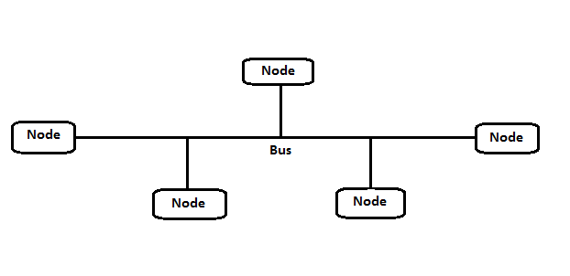

Fig. 1 Bus Topology

The Fig. 1 describes bus topology, in which all the nodes of the network are connected with single cable/wire. This single cable is also known as bus. This cable is the backbone of network, in which whole nodes depends upon the base cable.

* 1. **Ring Topology**

When the different nodes on the network are connected in the form of ring like structure as shown in Figure, is known as ring topology. Probably the ring topologies are the least likely to be used in a home network. The topology is used to make ring networks is called Token Ring, which is more expensive as compared to the other types of network topologies.Inring technology for networking, nodes communicate by sending an information data around a ring until the data finds its destination the node. This technology is very polite in that a data will not be sent by another node until the data circulating at a given time finds its destination.

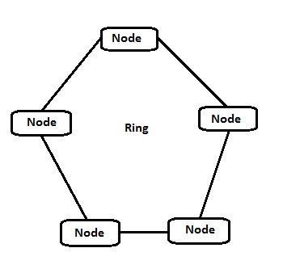

Fig.2 Ring Topology

Fig.2 defines the ring topology, in which whole nodes are connected in the ring form. In this topology if one of the node get distorted then whole network becomes fail.

* 1. **Star Topology**

Star topology is one of the most commonly used network topology in which each of the nodes on a network connected to a central controlled hub node. This network topology has a major disadvantage that if the central controlled hub node fails, all nodes connected to that hub node would be disconnected from network. A major disadvantage of this network topology is the system high dependence on the functioning of the central controlled hub node.

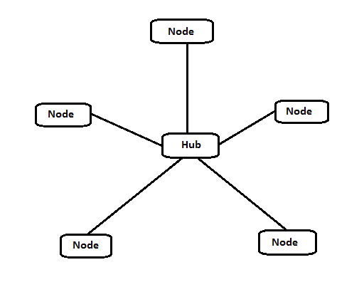

Fig.3 Star Topology

Fig.3 describes star topology, in which all the nodes of the network are connected to the master node, which is also known as hub node. Master/Hub node is the brain of this network, which provides the route to each node to communicate with other. In star topology, if hub node gets down then the whole network becomes fail.

* 1. **Mesh Topology**

In mesh topology, all nodes are connected to the other nodes with separate cables, there is no meaning of shape like star, ring or tree topology. Mesh topology is used in special cases like low number of computers only, because as the number of computers increases the number of cables also increases. In mesh topology nodes of the network is connected to the other nodes with different ways. In full mesh topology network, the number of connections can be calculated by the formula:

Total No. of Connections = N*(N- 1)/2

In this formula, N refers to the number of the devices such as computers, scanners and printers which are connected to the network.

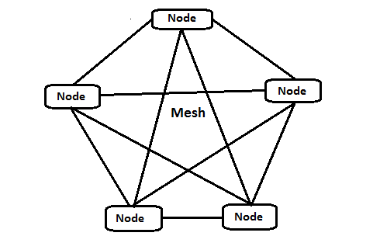 Fig.4 Mesh Topology

As shown in the Fig.4 in mesh topology, each node in the network is connected to the other nodes of the network. The connection of the each node with other makes it complex network. In this network the chances of gets down of network is very less.

**4. Optisystem Software**

In an industry where cost effectiveness and productivity are imperative for success, the award winning OptiSystem can minimize time requirements and decrease cost related to the design of optical systems, links, and components. OptiSystem is an innovative, rapidly evolving, and powerful software design tool that enables users to plan, test, and simulate almost every type of optical link in the transmission layer of a broad spectrum of optical networks from LAN, SAN, and MAN to ultra-long-haul. It offers transmission layer optical communication system design and planning from component to system level, and visually presents analysis and scenarios.

4.1 SPECIFIC BENEFITS

* Provides global insight into system performance
* Assesses parameter sensitivities aiding design tolerance specifications
* Visually presents design options and scenarios to prospective customers
* Delivers straightforward access to extensive sets of system characterization data
* Provides automatic parameter sweep and optimization
* Integrates with the family of Optiwave products

4.2 Applications

Created to address the needs of research scientists, optical telecom engineers, system integrators, students and a wide variety of other users, OptiSystem satisfies the demand of the evolving photonics market for a powerful yet easy to use optical system design tool.

OptiSystem enables users to plan, test, and simulate (in both the time and frequency domain):

* Optical network designs including OTDM, SONET/ SDH rings, CWDM, DWDM, PON, Cable, OCDMA
* Single-mode/multi-mode transmission
* Free space optics (FSO), Radio over fiber (ROF), OFDM (direct, coherent)
* Amplifiers and lasers (EDFA, SOA, Raman, Hybrid, GFF optimization, Fiber Lasers)
* Signal processing (Electrical, Digital, All-Optical)
* Transmitter and receiver (direct/coherent) sub system design
* Modulation formats (RZ, NRZ, CSRZ, DB, DPSK, QPSK, DP-QPSK, PM-QPSK, QAM-16, QAM-64)
* System performance analysis (Eye Diagram/ Q-factor/BER, Signal power/OSNR, Polarization states, Constellation diagrams, Linear and non-linear penalties)

4.3 Key Functionality

1. Component Library

The OptiSystem Component Library includes hundreds of components that enable you to enter parameters that can be measured from real devices. It integrates with test and measurement equipment from different vendors. Users can incorporate new components based on subsystems and user-defined libraries, or utilize co-simulation with a third party tool such as MATLAB or SPICE.

### 2. Integration with Optiwave Software Tools

OptiSystem allows you to employ specific Optiwave software tools for integrated and fibre optics at the component and circuit level: OptiSPICE, OptiBPM, OptiGrating, and OptiFiber.

### 3. Mixed signal representation

OptiSystem handles mixed signal formats for optical and electrical signals in the Component Library. OptiSystem calculates the signals using the appropriate algorithms related to the required simulation accuracy and efficiency.

### 4. Quality and performance algorithms

In order to predict the system performance, OptiSystem calculates parameters such as BER and Q-Factor using numerical analysis or semi-analytical techniques for systems limited by inter-symbol interference and noise.

### 5. Advanced visualization tools

Advanced visualization tools produce OSA Spectra, signal chirp, eye diagrams, polarization state, constellation diagrams and much more. Also included are WDM analysis tools listing signal power, gain, noise figure, and OSNR per channel.

### 6. Data monitors

You can select component ports to save the data and attach monitors after the simulation ends. This allows you to process data after the simulation without recalculating. You can attach an arbitrary number of visualizers to the monitor at the same port.

### 7. Hierarchical simulation with subsystems

To make a simulation tool flexible and efficient, it is essential to provide models at different abstraction levels, including the system, subsystem, and component levels. OptiSystem features a truly hierarchical definition of components and systems, allowing the simulation to be as detailed as the desired accuracy dictates.

### 8. Powerful Script language

You can enter arithmetical expressions for parameters and create global parameters that can be shared between components and subsystems using standard VB Script language. The script language can also manipulate and control OptiSystem, including calculations, layout creation and post-processing.

### 9. State-of-the-art calculation data-flow

The Calculation Scheduler controls the simulation by determining the order of execution of component modules according to the selected data flow model. The main data flow model that addresses the simulation of the transmission layer is the Component Iteration Data Flow (CIDF). The CIDF domain uses run-time scheduling, supporting conditions, data-dependent iteration, and true recursion. OptiSystem Optical Communication System and Amplifier Design Software

### 10. Report page

A fully customizable report page allows you to display any set of parameters and results available in the design. The produced reports are organized into resizable and moveable spreadsheets, text, 2D and 3D graphs. It also includes HTML export and templates with pre-formatted report layouts.

### 11. Bill of materials

OptiSystem provides a cost analysis table of the system being designed, arranged by system, layout or component. Cost data can be exported to other applications or spreadsheets.

### 12. Multiple layouts

You can create many designs using the same project file, which allows you to create and modify your designs quickly and efficiently. Each OptiSystem project file can contain many design versions. Design versions are calculated and modified independently, but calculation results can be combined across different versions, allowing for comparison of the designs.

## 4.4 FEATURES

OptiSystem provides the most comprehensive optical communication and photonics design suite for optical design engineers. Its key features include:

### Transmitters library

OptiSystem’s Transmitters library contains an extensive selection of optical sources (Fabry-Perot, DFB, and VCSEl),electrical and optical signal pulse  
generators, optical modulators (EA, MZ), electrical modulators and coders (QAM, PAM, FSK, OFDM) and multi-mode signal generators (Laguerre-Gaussian, Hermite-Gaussian).

Designers can choose between advanced physical-based or measurement-based (empirical) models for modelling the static and dynamic behaviour of semiconductor lasers. Our physical-based models include 1D and 2D multi-mode laser rate equations, providing designers with the ability to switch between bulk laser rate models and the transmission line matrix method (TLMM).

### Receivers library

The Receivers library contains all the building blocks needed to accurately model optical communication receiver sub-systems. Components include regenerators (clock/data recovery, 3R), electronic equalizers, threshold detectors, decision circuits for PSK/QAM modulation, PIN and APD photo-detectors, demodulators (OFDM, frequency, phase amplitude), decoders (PAM, QAM, PSK, etc.), and digital signal processing (DSP) tool sets for single and dual polarization coherent PSK and QAM systems.

### Optical fibers

Advanced, highly parameterized, optical fiber models can be used to characterize single mode and multi-mode signal propagation; including linear (dispersion), stochastic (PMD), and non-linear impairments (FWM, self-phase modulation, and cross-phase modulation). Using OptiSystem’s Bidirectional optical fiber component, it is possible to model and measure Rayleigh, Brillouin and Raman scattering effects.

### Amplifiers

A comprehensive suite of steady state and dynamic optical amplifier models is provided, including advanced doped fiber models (Er, Er multi-mode, Er-Yb, Yb, Yb multi-mode, Tm, Pr) for detailed physical fiber amplifier design; EDFA and EDFA black box (gain spectrum, noise figure measurements) for WDM network systems design; dynamic and average power Raman models; and 1D/2D semiconductor optical amplifier models (lumped rate equation, travelling wave, TLMM). Electrical domain amplifiers are also provided for receiver design (Transimpedance, automatic gain control and limiting amplifier applications).

### Network design tools

Network design tools include ideal and non-ideal models for optical switches, multiplexers, de-multiplexers, array waveguides (AWGs), fiber connectors, and PMD emulators.

### Signal processing

Signal processing tools are provided for manipulating optical, electrical and binary signals. Functions and operations include bias generators, gain, signal addition and subtraction, normalizers, electrical differentiators and integrators, down-samplers, serial-parallel and parallel-serial converters, electrical flip flops, and electrical/binary logic operators.

### Visualization tools

Visualization and post-simulation analysis tools include BER test sets and analyzers, eye diagram analyzers, spectrum analyzers, oscilloscopes, optical time domain viewers, power meters, polarization analyzers, spatial visualizers, encircled flux, DMD analyzer, photonic all parameter analyzer, filter analyzer, and S-parameter extractor.

**Chapter 2: Performance Investigation FSO Network under Different Weather Conditions**

1. **Introduction**

Long distance transmission and high data rate is the obligation in the optical communication which leads to improvements that can dispose of the need for costly alterations from optical to electrical signal and vice versa [43].In Free space optical (FSO) communication, free space is used as medium for transfer information of an optical carrier. In recent past, FSO communication has recently exert influenced large scale interest within the investigation community, since it can be auspicious for number of applications [44]. FSO communication free of licensing, because operates at very high frequency. FSO communication is a line-of-sight (LOS) technology, which is operating the optical communications with 1st, 2nd and 3rd transmission windows respectively at wavelengths of 850nm, 1300 nm and 1550nm. These wavelengths of transmission windows have attenuation less than 0.2dB/km, which can use the same commercial components of an optical fiber [45]. The adherence and individuality of the link is highly atmospheric factors dependent such as rain, fog, dust, smog and heat. FSO components are embracing three stages: transmitter to broadcast an optical radiation over the atmosphere, free space transmission channel where the turbulent odd factors like cloud, rain, smoke, gases, temperature variations, fog and aerosol exists and receiver to process the received signal [46]. Larger bandwidth, higher gain of antenna, better privacy/security, smaller antenna and component sizes, and lower component costs are the advantages of FSO communication systems. Due to these advantages, FSO has been widely used in applications like space communications, temporary installations of network, safety add-on for important fiber connections, aircraft-to-aircraft communications, the last-mile access, and military applications [47]. In order to enhance the performance of FSO systems, various techniques of generation are used. These techniques are known as the Optical Code Division Multiple Access based Spectral Amplitude Coding system (OCDMA Based SAC System), High Speed Long Reach OFDM (Orthogonal Frequency Division Multiplexing) Schemes based systems and WDM scheme based System [48]. In FSO communication, medium of the transmission-receiving is an atmosphere and there are some un-ignorable environmental challenges. The mostof the atmospheric phenomenon like scintillation, geometric losses, absorption, atmospheric turbulence, atmospheric attenuation, scattering [49] andattenuation due to weather conditions of atmosphere [50].Several considerations have been supervised on the different weather of different regions and the existence of beam wander has been investigated by correlating bit error ratio with beam width [51]. In terrestrial region, the optical link attenuation measurements results have been performed experimentally for visibilities ranging from 9-12 km. With operating wavelength of 780nm a visibility and attenuation have been calculated over a distance for a FSO link [52].

In Canada region, different sorts of modulations have been studied to resolve the rain attenuation effect on FSO performance. It was realized that as compared to the low rain rate, the signal-to-noise ratio (SNR) and bit-error rate (BER) has been severely degraded in the results with a high rain rate [53].

In Changsha, China region, point to one point (P2OP) FSO communication has been established in heavy rain weather. Further it was realized that the potentiality of communication links with bit rate up to 1.5 Gbps isup to 3 km with WDM spectrum slicing (SS) technique in heavy rain season [54]. During this course of work, point-to-multi-point (P2MP) communication in a hybrid topology based network with data rate up to 5 Gbps/channel with the acceptable results has been investigated. The results at every node of the network have been observed for all weather conditions. The attenuation factors with the time duration of weather seasons are described in Table 1. From This table, it has been adhered that the rainy season shows the maximum attenuation throughout all seasons. It can upgrade the system capacity to achieve high speed network facilities. FSO will functions properly with using the optical repeaters after an appropriate transmission distance.

Table 1: Seasonal details with respective attenuation.

|  |  |  |
| --- | --- | --- |
| **Weather Season** | **Time Duration** | **Attenuation (dB/km)** [6] |
| Clear Season | March to Last June | 0.23 |
| Rain Season | July to September & September to October | 9.64 |
| Fog Season | December to February | 2.37 |

1. **Proposed Hybrid Topology Network**

In this network, different optical source has been used for the generation of each input signal. An optical multiplexer and de-multiplexer have been used according to their application of combining and for slicing the signal to the number of channels with their wavelengths and at the receiver end, photo-detector has been used [55].In literature, in WDM technology, the optical transmission spectrum is distributed into a number of different frequency/wavelength bands, with a single wavelength communication channel operating at desired rate. In optical communication system, WDM is a technology in which bidirectional communications is used over fiber and capacity multiplication [56].In this present piece of work,for the implementation of a bit stream of 5 Gbps data rate per channel, NRZ modulation format with Pseudo code generator has been used. Further, with the channel spacing of 0.5 nm the twelve multiplexed signals are transmitted over a FSO channel in the rings and fifteen signals are transmitted over a high speed link between two rings.

The proposed hybrid network architecture isshown in the Fig.1.The12 channels of different wavelengths which start from 1550nm have been generated using the 12-continuous wave (CW) laser sources. At each node, 9 channels have been dropped out and the rest 3 channels have been used for the transmission between other nodes. According to the weather conditions,the input power of CW laser has been set like 20 dBm for a Clear season, 30 dBm for foggy season and 40 dBm for the rainy season. The Mach-ZehnderModulator has been used to modulate the optical signals. The 12:1 multiplexer has been used to multiplex/combine the channels for the transmission over a single channel. Then the modulated signal has been transmitted over an FSO network with 11 nodes spreading over different lengths. The architecture of transmitter and receiver is shown in Fig.2.

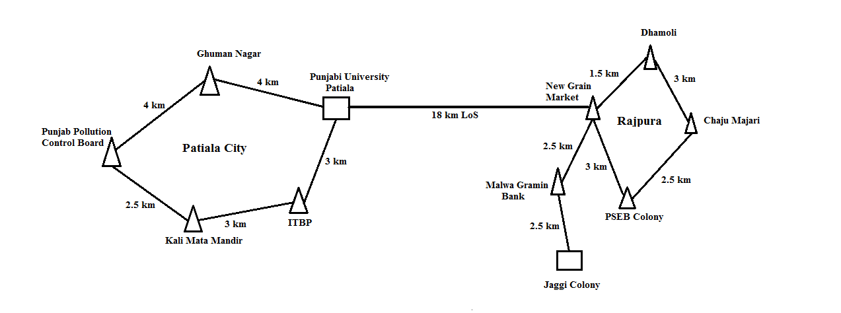

**Fig. 1.** Architecture of FSO network.

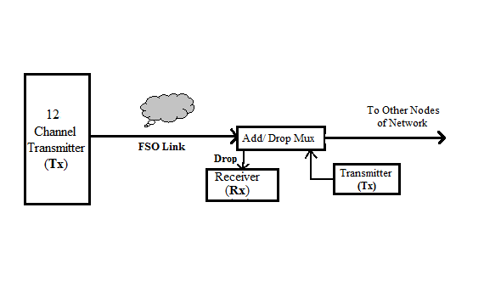

**Fig. 2.** Architecture of transmitter and receiver.

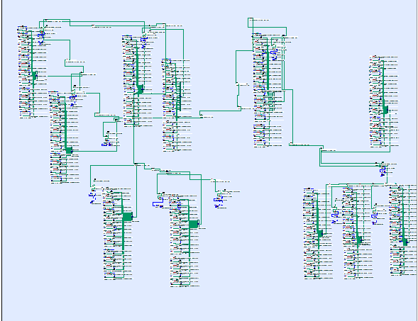

Fig. 3. Simulated setup of clear season

The different parameters of FSO channel which are used in simulation has been explained in Table 2. In FSO channels, the propagation distance between transmitter and receiver end is defined by Range parameter.

Table 2: Parameters of FSO channel.

|  |  |
| --- | --- |
| **Parameters** | **Range** |
| Input power | Clear weather: 20 dB  Foggy weather: 30 dB  Rainy weather: 40 dB |
| Wavelength | 1550 nm onwards (12 channels with equal channel spacing of 0.5 nm and 15 channels for high speed link between two rings) |
| Bit Rate | 5 Gbps |
| Transmitting Distance | Punjabi University to Ghuman Nagar: 4 km  Ghuman Nagar to Punjab Pollution Control Board: 4 km  Punjab Pollution Control Board to Kali Mata Mandir : 2.5 km  Kali Mata Mandir to ITBP: 3 km  ITBP to Punjabi University: 3 km  Punjabi University to New Grain Market Rajpura : 18 km  New Grain Market to Dhamoli : 1.5 km  Dhamoli to ChajuMajari : 3 km  ChajuMajari to PSEB Colony : 2.5 km  PSEB Colony to New Grain Market : 3 km  New Grain Market to MalwaGramin Bank : 2.5 km  MalwaGramin Bank to Jaggi Colony : 2.5 km |
| Extinction Ratio | 30 dB |
| Attenuation | Varying (According To Weather condition defined in Table 1) |
| Transmitter Aperture Diameter | 5 cm |
| Receiver Aperture Diameter | 20 cm |
| Beam Divergence | 2 mrad |

An optical add-drop multiplexer (OADM) has been used to receive a signal from drop port and it will transmit another signal from add port at each node of ring network. Very high attenuation (9.67 dB/km) has been observed in case of the rainy season, which leads the unacceptable performance. Hence, for the acceptable performance and continuousworking of network, the repeaters are needed after every 1 km of transmission distance. On the receiver end, with tuning the filter to desired wavelength, any signal from twelve channels can be received at every node of the network. At the receiving end of every node, for the conversionofan optical signal to electrical signal, the PIN/Avalanche photo-detector has been used.

1. **Results and discussions**

In this Report, the Optisystem simulation software of Optiwave has been usedto carry out simulations. The result representations have been described that the proposed hybrid network is performing well and it is suitable for FSO communicationwith bit rate of 5 Gbps during all seasons.The Fig. 4 shows the variations of Q factor with respect to the used wavelengths at each node for clear season, in whichthe Node 1(4 km) has high Q factor than other node. The reason behind it is that this node is the first transmitting node in the network. The average variation of Q-factor has been shown by Node 2(2.5 km), Node 3(3 km), Node 5(18 km) and Node 11(2.5 km) as compared to the rest nodes. The rest nodes Node 4(3 km), Node 6(1.5 km), Node 7(3 km), Node 8(2.5 km), Node 9(3 km) and Node 10(2.5 km) shows the minimum Q-factor then other nodes. Fig.5 shows the output eye diagram of each node of the designed network.

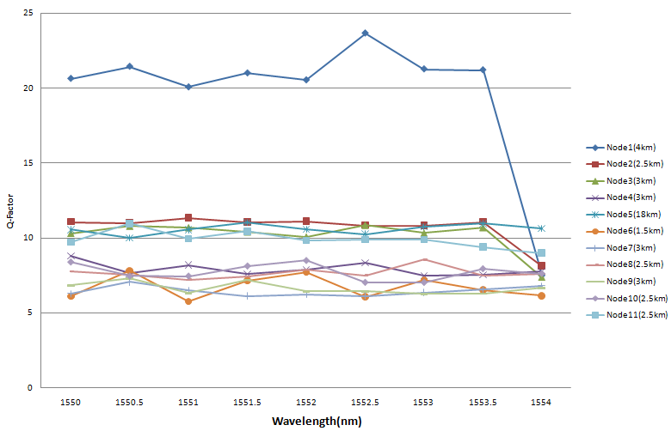

**Fig. 4.** Graph of variation of Q factor with respect to the used wavelengths at each node for clear season.

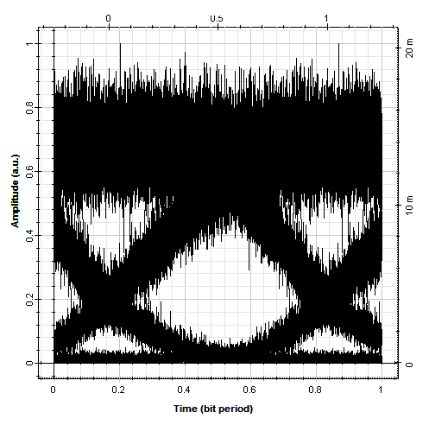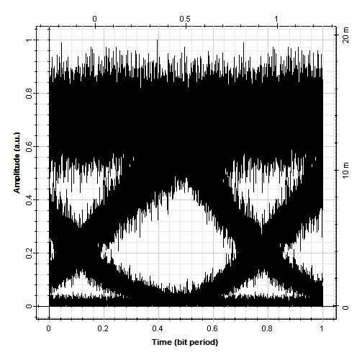

(a) (b)

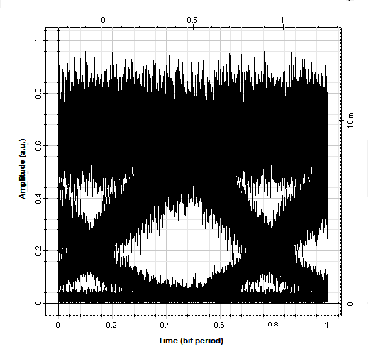

(c)

**Fig.5**.The received output eye diagrams at different nodes for clear season.

TheFig. 6 describes the variation in Q-Factor with wavelength for foggy season. Node 1(4 km) and Node 11(2.5km) have high Q-Factor as compared to other nodes, because these nodes are the starting and last nodes of the proposed network. The attenuation factor in the foggy season is average than these two other seasons. The rest of the nodes show the greater Q-factor then the acceptable value. The output received eye diagrams of every node have been described in the Eye diagrams Fig. 7.

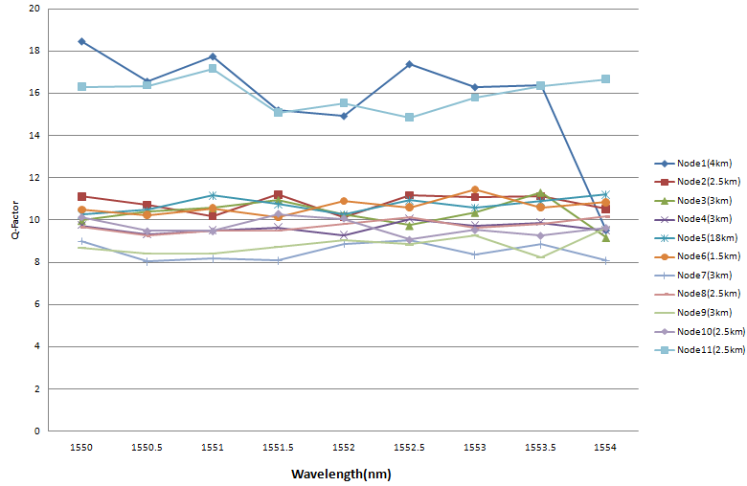

**Fig.6.** Graph of Q factor with respect to the used wavelengths at each node for foggy season.

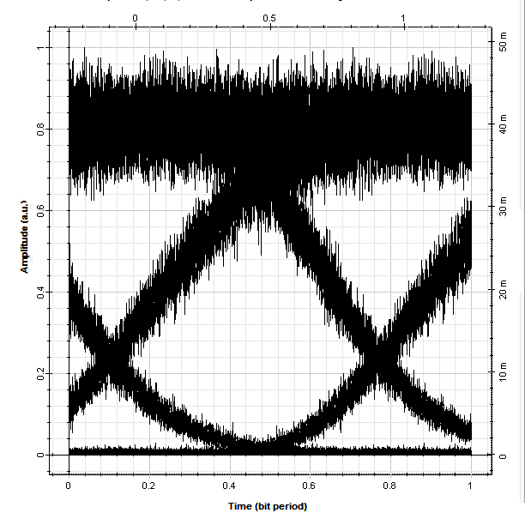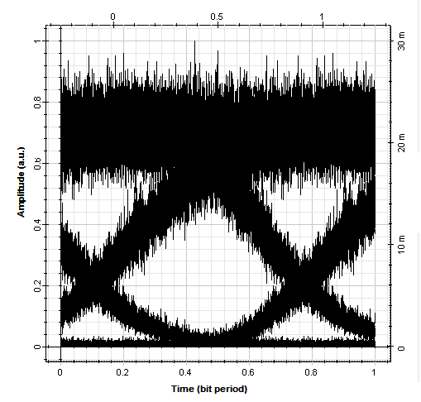

(a) (b)

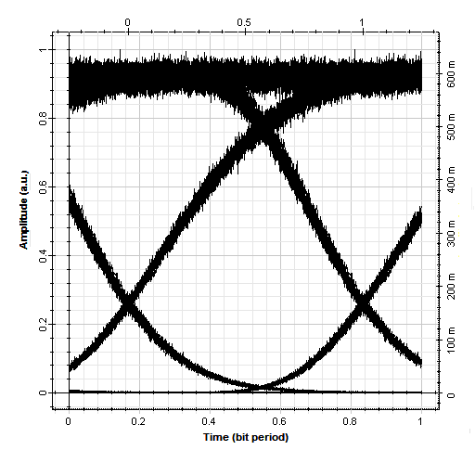

(c)

**Fig.7.** The received output eye diagram (1550 nm) at different nodes for foggy season

During the rainy season, the droplet can lead to the irregularities like scatteringand atmospheric attenuation which will decrease possibilities of the communication link range. In order to overcome the scattering and atmospheric attenuationdue to the raindrops and increase the possibilities of FSO communication link range, the optical repeater or optical amplifier can be used. Fig. 8 describes the variation of Q-factor with respect to wavelength used. The performance of the proposed network during this season is better as compared to the other season. The reason behind is that due to the high attenuation (9.64 dB/km) of rainy season, the optical amplifier has been used after 1 km of FSO channel. The received output eye diagrams of node have been shown in Fig. 9.

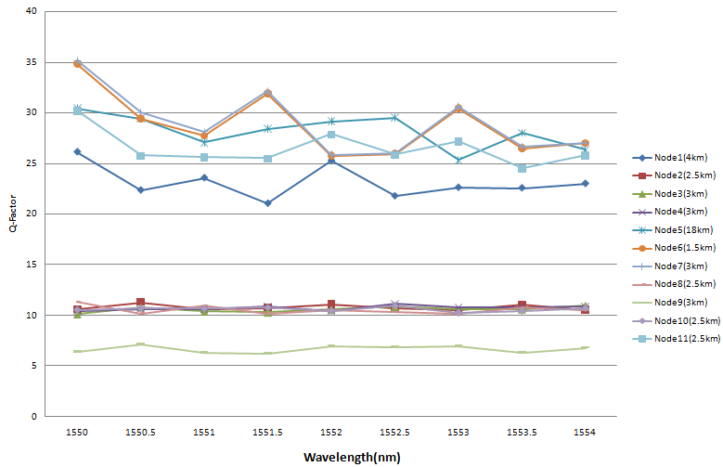

**Fig.8.** Graph of Q factor with respect to the used wavelengths at each node for rainy season.

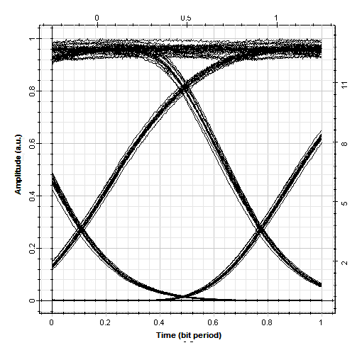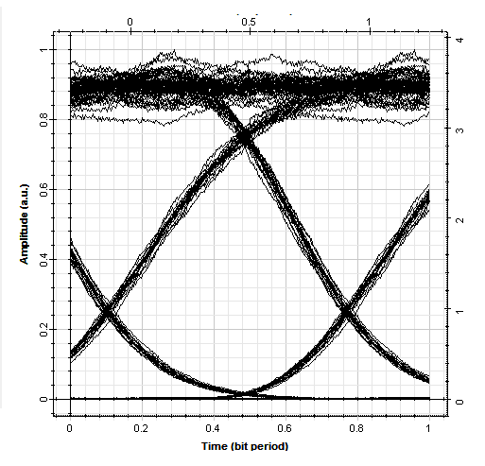

(a) (b)

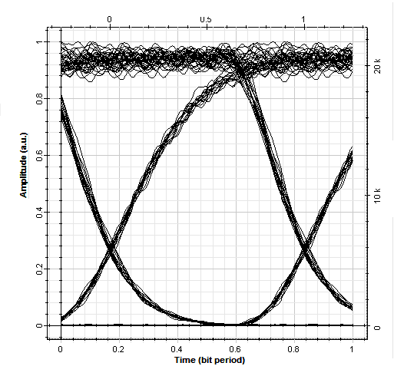

(c)

**Fig.9**. the received output eye diagram (1550 nm) at different nodes for rainy season.

1. **Conclusions**

In this work, an FSO communication network has been proposed throughout the Patiala and Rajpura region, Punjab, India. The weather conditions of this region have also been analyzed. The FSO communication link performance through all-weather seasons of Patiala and Rajpura region has been observed. In all the weather seasons, the resultsat each node of the network have been calculated in terms of BER and Q-Factor. It has been concluded that in rainy season, there is a need of repeaters or amplifiers after every 1 km due to more attenuation than the other clear and foggy seasons. Further, it has been concluded that the rainy season output Q-Factor is better than other seasons.

**References:**

[1]. www.Freespaceoptics.Com.

[2].S. Bloom, E. Korevaar, J. Schuster, H. Willebrand, ‘Understanding the performance of FSO’, Journal of Optical Networking. Vol. 2, No. 6, Pp. 178-200, June 2003.

[3]. Fsona Unveils 2-5-Gbps Free-Space Optical Systems,September 5, 2012.

[4]. M. Khalighi, M. Uysal, “Survey

On FSO Communication: A Communication Theory Perspective”, IEEE Communication SurveyTutorials, 2231–58, 16 June, 2014.

[5]. H. Pham, N. Dang, L. Vu, H. Bui, “A Survey OfPerformance Improvement Methods For Free-Space Optical Communication Systems”, In Proceedings Of International Conference On Advanced Technologies For Communications, Hanoi, Vietnam, pp-15–17 October 2014.

[6]. Z. Ghassemlooy, S. Arnon, M. Uysal, Z. Xu, J.Cheng, “Emerging Optical Wireless Communications- Advances And Challenges”, IEEE J Select Areas Communication, Vol. 33, pp:1738–49; September 9, 2015.

[7]. J. Kaufmann, “FSO Communications: An Overview Of Applications And Technologies,” In Proceedings Of The Boston IEEE Communications Society Meeting, 2011.

[8]. H. A.Willebrandand B.S. Ghuman, “Fiber Optics Without Fiber,” IEEE Spectrum,

Vol. 38, No. 8, Pp. 40–45, 2001.

[9]. V. Sharma And G. Kaur, “High Speed, Long Reach OFDMFSOTransmission Link Incorporating OSSB And OTSB Schemes,”Optik,

Vol. 124, No. 23, Pp. 6111–6114, 2013.

[10]. R. K. Z. Sahbudin, M. Kamarulzaman, S. Hitam, M.Mokhtar, Ands. B. A. Anas, “Performance Of SAC-OCDMA-FSO Communication Systems,” Optik, Vol. 124, No. 17, Pp. 2868–2870, 2013.

[11]. G. Shaulov, J. Patel, B. Whitlock, P.Mena, And R. Scarmozzino, “Simulation-Assisted Design Of FSO Transmission Systems,” In Proceedings Of The Military Communications Conference (Milcom’05), Vol. 2, Pp. 918–922 , October 2005.

[12]. H. H. Refai, J. J. Sluss, Jr., And H. H. Refai, “Optical Interference On Free-Space Optical Transceivers,”Frontiers In Optics – 87th Optical Society Of America Annual Meeting, Tucson, Az., 2003.

[13]. H. H. Refai, J. J. Sluss, Jr., H. H. Refai, “Interconnection Of IS-95 CDMA Microcells Using Free-Space Optical Links,” Proceedings Of The 1st IEEE And IFIP International Conference On Wireless And Optical Communications Networks (WOCN 2004), Muscat, Oman, Pp. 78-81, June 7-10, 2004.

[14]. H. H. Refai, J. J. Sluss, Jr., And H. H. Refai, “The Use Of Free-Space Optical Links For Catv Applications,” Accepted To SpieOpto Ireland, Dublin, Ireland,April 4-5, 2005.

[15]. S. Vigneshwaran, I. Muthumani, And A. S. Raja, “Investigations On FSO

Communication System,” In Proceedings Of The International Conference On Information Communication & Embedded Systems (Icices ’13), IEEE, Chennai,India, Pp. 819–824, February 2013.

[16]. A. K. Rahman, M. S. Anuar, S. A. Aljunid, And M. N. Junita, “Study Of RainAttenuation Consequence In Free Space Optic Transmission,” In Proceedings Of The2ndmalaysia Conference On Photonics Telecommunication Technologies (Nctt-Mcp ’08), IEEE, Putrajaya, Malaysia, Pp. 64–70, August 2008.

[17]. N. Kumar And A. K. Rana, “Impact Of Various Parameters On The Performance Of FSO Communication System,” Optik, Vol. 124, No. 22, Pp. 5774–5776, 2013.

[18]. H. A. Fadhil, A. Amphawan, H. A. B. Shamsuddin Et Al.,“

Optimization Of FSO Parameters: An Optimum Solution For Bad Weather Conditions,” Optik, Vol. 124, No. 19, Pp.3969–3973, 2013

[19]. <Http://Www.Laseroptronics.Com/Index.Cfm/Id/57-66.Html>.

[20]. J.SinghAnd N. Kumar, “Performance Analysis Of Different Modulation Format On FSO Communication System,” Optik, Vol. 124, No. 20, pp. 4651–4654, 2013.

[21]. S. A. Zabidi, W. Al Khateeb, R. Islam, And A. W. Naji, “Investigating Of Rain Attenuation Impact On FSO Propagation In Tropical Region,” In Proceedings Of The 4th International Conference On Mechatronics (Icom ’11), Pp. 1–6, IEEE, Kuala Lumpur, Malaysia, May 2011.

[22]. S. A. Al- Gailani, A. B. Mohammad, And R. Q. Shaddad, “Enhancement Of FSO Link In Heavy Rain Attenuation Using Multiple Beam Concept,” Optik, Vol. 124, No. 21, Pp. 4798–4801, 2013.

[23]. M. Ijaz, Z. Ghassemlooy, J. Pesek, O. Fiser, H. Le Minh, And E. Bentley, “Modeling Of Fog And Smoke Attenuation In FSO Communications Link Under Controlled Laboratory Conditions,” Journal Of Lightwave Technology, Vol. 31, No. 11, Article Id 6497447, Pp. 1720–1726, 2013.

[24]. Z. Ghassemlooy, J. Perez, And E. Leitgeb, “On The Performance of FSO Communications Links Under Sandstorm Conditions,” In Proceedings of The 12th International Conference on Telecommunications (Contel ’13), pp. 53–58, IEEE, Zagreb, Croatia, June 2013.

[25]. K. Rammprasath And S. Prince, “Analyzing The Cloud Attenuation on The Performance of FSO Communication,” In Proceedings of The 2nd International Conference On Communication And Signal Processing (ICCSP’13), Pp. 791–794, Melmaruvathur, India, April 2013.

[26]. S. A. Al-Gailani, A. B. Mohammad, R. Q. Shaddad, And M. Y. Jamaludin, “Single And Multiple Transceiver Simulation Modules For Free-Space Optical Channel In Tropical Malaysian Weather,” In Proceedings Of The IEEE BusinessEngineering And Industrial Applications Colloquium (Beiac ’13), Pp. 613–616, Langkawi, Malaysia, April 2013.

[27]. I. K. Son, S. Mao, “A Survey Of FSO Networks”, Digital

Communications And Networks 3, pp. 67–77, 2017.

[28]. V.W. Chan, Optical satellite networks, IEEE/OSA J. Lightwave Technology, pp. 2811–2827, 21 Nov. 2003.

[29]. V.W. Chan, Free-space optical communications, IEEE/OSA J. Light. Technol., pp. 4750–476224, December 2006.

[30].C.C. Davis, I.I. Smolyaninov, S.D. Milner, Flexible optical wireless links and networks, IEEE Commun. Mag. Vol. 41, pp. 51–57, 2003.

[31]. A. Mahdy, J.S. Deogun, Wireless optical communications: a survey, in: Proceedings of the IEEE Wireless Communications and Networking Conference (WCNC)'04, Atlanta, GA, pp. 2399–2404, Mar. 2004.

[32]. D.J. Heatley, D.R. Wisely, I. Neild, P. Cochrane, Optical wireless the story so far, IEEE Commun. Mag. Vol. 36, pp. 72–74, 79–82, Dec. 1998.

[33].J.C. Juarez, A. Dwivedi, A.R. Hammons, S.D. Jones, V. Weerackody,

R.A. Nichols, Free-space optical communications for next-generation military networks, IEEE Commun. Mag. Vol. 14, pp. 46–51, Nov. 2006.

[34]. K.-D. Langer, J. Grubor, Recent developments in optical wireless communications using infrared and visible light, in: Proceedings of the 9th International Conference on Transparent Optical Networks (ICTON), Rome, Italy, pp. 146–151, July 2007.

[35] M. Kavehrad, S. Jivkova, Indoor broadband optical wireless communications optical subsystems designs and their impact on channelcharacteristics, IEEE Wireless Commun. Vol. 10, pp. 30–35, April 2003.

[36]. T. Komine, M. Nakagawa, Fundamental analysis for visible-light communication system using led lights, IEEE Trans. Consum. Electron. Vol. 50, pp. 100–107, February 2004.

[37]. A. Malik And P. Singh, “FSO: Current Applications And Future Challenges”, Hindawi Publishing Corporation, International Journal Of Optics, Volume 2015, Article Id 945483, 7 Pages, 2015.

[38]. R. K. Z. Sahbudin, M. Kamarulzaman, S. Hitam, M. Mokhtar, And S. B. A. Anas, “Performance of SAC OCDMA- FSO Communication Systems,” Optik,Vol. 124, No. 17, Pp. 2868–2870, 2013.

[39]. V. Sharma and G. Kaur, “High speed, long reach OFDM-FSO transmission link incorporating OSSB and OTSB schemes,” Optik, Vol. 124, No. 23, pp. 6111–6114, 2013.

[40]. H. A. Fadhil, A. Amphawan, H. A. B. Shamsuddin, “ Optimization of FSO parameters: an optimum solution for bad weather conditions,” Optik,vol. 124, no. 19, pp. 3969–3973, 2013.

[41]. <http://cgwb.gov.in/District_Profile/Punjab/Patiala.pdf>

[42]. http://www.bharatonline.com/punjab/patiala/weather.html

[43]. S. Singh, R.S. Kaler, “Comparison of Pre-, Post- and Symmetrical Compensation for 96 Channel DWDM System using PDCF and PSMF”, Optik, Vol. 124, pp. 1808– 1813, 2013.

[44]. V. W. S. Chan, “Free-space optical communications",Journal of Lightwave Technology, Vol. 24, no. 12, pp. 4750-4762, 2006.

[45]. Z. Ghassemlooy, S. Arnon, M. Uysal, Z. Xu, J. Cheng, “Emerging Optical Wireless Communications- Advances And Challenges”, IEEE Journal Select Areas Communication, Vol. 33, pp.1738–49, 2015.

[46].Fsona Unveils 2-5-Gbps Free-Space Optical Systems, 2012.

[47]. J. Juarez, A. Dwivedi, A. Hammons, Jr., S. Jones, V. Weerackody, and R. Nichols, “Free-Space Optical Communications for Next-Generation Military Networks”,IEEE Communications Magazine, Vol. 44, no. 11, pp. 46–51, 2006.

[48]. A. Malik And P. Singh, “FSO: Current Applications And Future Challenges”,Hindawi Publishing Corporation, International Journal Of Optics, Vol. 2015, Article Id 945483, 7 Pages, 2015.

[49]. H. A. Fadhil, A. Amphawan, H. A. B. Shamsuddin,“Optimization Of FSO Parameters: An Optimum Solution For Bad Weather Conditions”,Optik, Vol. 124, No. 19, pp.3969–3973, 2013.

[50].S. A. Al-Gailani, A. B. Mohammad, And R. Q. Shaddad, “Enhancement of FSO Link in Heavy Rain Attenuation Using Multiple Beam Concept”,Optik, Vol. 124, No. 21, pp. 4798–4801, 2013.

[51]. L. Wing, F. Ying, “Research on the Relationship of BER of FSO System with Beam Width in the Presence of the Beam Wander”, Journal of Opt. Opt-electron Technology, Vol. 8, pp. 26–30, 2010.

[52]. A. D. Kora, R. Hontinfinde, T. Ouattara, “FSO Attenuation Model For Visibilities Ranging From 9 To 12 Km”, The 10th International Conference On Future Networks And Communications (FNC 2015),Procedia Computer Science, Vol. 56, pp. 260 – 265, 2015**.**

[53]. S. Salamah, M. A. Alsubaie, M. J. Alnaser and O. Mahmoud, “Free Space Optical Communications Performance Under The Effect of Rain Attenuation in Canada”, International Journal of Engineering Research and Application, Vol. 6, no. 12, pp.64-68, 2016.

[54]. F. Rashidi, J. He, L. Chen, “Spectrum Slicing WDM For FSO Communication Systems under the Heavy Rain Weather”, Optics Communications, Vol. 387, pp. 296–302, 2017.

[55]. J. M. Senior, “Optical Fiber Communications”, Pearson Education, 3rd Edition, 2007.

[56]. Network Topology, Module 5, Broadcast Communication Networks, Version 2 CSE IIT, Kharagpur.